**...............................................**

**Challenge 3**

**...............................................**

**Challenge link--->** "<http://www.pythonchallenge.com/pc/def/equality.html> "

An image is displayed:

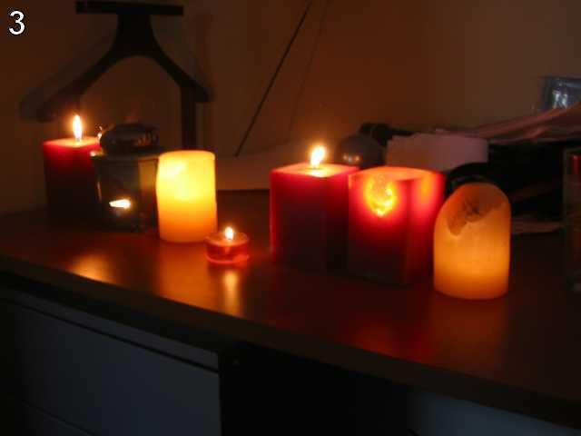

Hint is: " **One small letter, surrounded by EXACTLY three big bodyguards on each of its sides**. "

From hint we can get that we have to find one lowercase letter surrounded by exactly 3 uppercase letters on both sides [view-source](:http:/www.pythonchallenge.com/pc/def/equality.html)

From source code we get a bunch of characters inside a comment and from that we have to find all those lowercase letter which are exactly surrounded by three uppercase letters on both the sides.

So, I have written a python code (challenge_3.py) to find all the letters which are described above and stored them in a string.

The string we get as output is the answer and will help you to move to next the challenge.